IRIS Imager User Guide

Matt Limmer, Abby Evans, and Angelia Seyfferth

University of Delaware, Department of Plant and Soil Science

A user guide for IRIS Imager (version 1.0). User guide updated 10/1/20.

Table of Contents

**Section Page**

Theory 2

Before Running the Program 3

Running the Program 5

Output Data 14

# Code Requirements

The code is available as an executable (.exe) file that can be run as a standalone application. Prior to installing, view the Readme.txt file, which has instructions for downloading the Matlab runtime files that are required for the program to run. The program has not been tested on Macs, but should be executable. The program is also available as a .m file that can be run in Matlab provided the appropriate toolboxes are available. The code was written in Matlab R2018b and uses the following toolboxes:

* Curve fitting toolbox
* Image processing toolbox
* Signal toolbox
* Statistics and machine learning toolbox

The k-means image cluster analysis in the image processing toolbox was introduced in Matlab R2018b, so earlier versions of Matlab will be unable to run the uncompiled code.

The file “AdjustableParameters.xlsx” will need to be located in the same directory.

# Theory

The program is able to analyze 3 different types of IRIS films: Iron (Fe) films deployed to monitor Fe removal from the film, Fe films deployed to monitor sulfide (S) formation on the Fe films, and manganese (Mn) films deployed to monitor the Mn removal from the film. For films where removal of the paint is desired, the program uses before (prior to deployment) and after (retrieved after deployment) images of the film to calculate removal. This approach should minimize the effect of paint heterogeneity. For S films, only an ending image is needed.

To process the images, the program aligns/straightens the film(s). The user selects the corners of the film(s). The program uses the left and right sides to determine the average angle of the sheet and rotates it to become vertical. The films are then translated such that the centers of the films are aligned. The aligned images are cropped and resized (to reduce file size, runtime, and noise). The user then selects the center point of each circle punched into the image (if any are present for film insertion).

Image analysis is performed in the CIE 1976 L*a*b* color space. This color space is considered to be similar to perception of the human eye and also separates color from lightness. Lightness (L*) ranges from 0 (black) to 100 (white) independent of the color. In the program, changes in L* are used to calculate Fe or Mn removal from the film. The percent removal at each pixel is calculated by:

Where is the L* value from the final image, is the L* value from the initial image, and is the L* value from a white film (i.e., completely removed). The % removal for each pixel is constrained between 0 and 100% removal. For properly aligned images, calculation at each pixel should reduce error arising from starting film heterogeneity, which primarily arises from brushstrokes left on the film. The percent removal at each pixel can be averaged across the entire film to calculate average removal or more complicated calculations can be used to determine changes in removal with depth (described in “Output Data” section).

The values of a* and b* can be used to identify changes in color of the film that occur during deployment. This is used for Mn films, which can precipitate Fe (orange) onto the Mn (brown) films. This Fe can be identified by the program using the change in b*, as Fe appears as an increase in b*. The program uses a thresholding approach to identify areas of Fe deposition.

Similar to Fe identification on Mn films, the value of b* can be used to distinguish between Fe and S on S films. Once Fe pixels are identified, the remainder are assumed to be S pixels. The L* value is used to assess the relative intensity of S (ranging from 0-100), where L*=0 (black) corresponds to the maximum S value of 100 and L*=100 (white) corresponds to the minimum S value of 0. Pixels identified as Fe are considered to have an S value of 0.

The program performs k-means cluster analysis of the starting and ending films in the L*a*b* color space. The cluster analysis can be used to quickly identify areas of spatial heterogeneity in the films. The average color of each cluster is matched to Munsell colors using the CIE ΔE2000 (CIEDE2000) color difference metric. The program shows each cluster area in its average Munsell color and reports the area and Munsell color of each cluster.

# Before Running the Program

Prior to running the program, images of the films are required and the adjustable parameters spreadsheet needs to be modified so that the correct analyses are performed.

* Scan in IRIS films. Program requires the starting film (only for Fe and Mn removal) and the ending film.
  + Starting and ending scans should be performed on the same scanner under the same scanner settings.
  + Scan the films in color using a lossless image format. Bitmap (.bmp) is recommended.
  + A scan resolution of 200 dpi is a good compromise between detail and file size, although higher resolution can be used.
  + When scanning in films, ensure that any holes punched into the film are visually distinguishable from the surrounding IRIS film. Typically, using a white background on starting films and a black background on ending films works well. Do this by placing a piece of black/white paper behind the film.
  + If the film does not fit into the scanner, scanning can be done in sections. Analysis by the program can either occur for each section or the images can be stitched together to create a single image for analysis.
* Modify the “AdjustableParameters.xlsx” spreadsheet
  + You can rename the spreadsheet and save it in any file location, but do not rename either of the tabs
  + Not all film types use all variables
  + Many of the parameters are unlikely to need adjusted
  + This workbook contains all the adjustable parameters in the program in the sheet “Parameters”. Each is described in detail below.
    - DPI – the scan resolution (dots per inch). This value is used for unit conversion. Throughout the program, the units are listed as inches, but units are derived from the units associated with this value. If the calculated size of the IRIS film does not match the actual size, the image may be compressed and the DPI should be adjusted to give accurate sheet size calculations (default = 200)
    - x_Crop – the number of pixels trimmed off the left/right edges of the film to avoid any edge effects (default = 10)
    - y_Crop – the number of pixels trimmed off the top/bottom edge of the film to avoid any edge effects (default = 10)
    - Scale_Factor – a factor to rescale images. A value of 1 indicates no rescaling, while a value of 0.5 indicates the image will be shrunk by ½. Rescaling the image reduces runtime and file size while also averaging pixels to reduce noise (default = 0.5)
    - Start_Upside_down_flag – a binary flag to rotate the starting image by 180° in the event that it was scanned in upside down (default = 0, i.e., image is right-side up)
    - End_Upside_down_flag – a binary flag to rotate the ending image by 180° in the event that it was scanned in upside down (default = 0, i.e., image is right-side up)
    - White_L – The lightness of a sheet with all the IRIS paint removed. Scan in an unpainted sheet to determine this value (default = 100).
    - Fe_b_Threshold – On Mn films Fe is often deposited resulting in a mixture of brown (Mn) and orange (Fe). The program identifies this hue change by comparing the change in b* from the starting film to the ending film. Pixels with Fe will have a higher b* (i.e., more yellow). If Fe pixels on Mn IRIS films are being over or under counted, try adjusting this value. For S films, this value is used to distinguish Fe and S pixels. Values of b* greater than this value are considered to be Fe pixels (i.e., more yellowish) (default = 20).
    - CircleRad_min – The program will mask out circles punched into the film by searching for circles in a given radius range. This value sets the lower radius range (default = 0.1 inches).
    - CircleRad_max – The program will mask out circles punched into the film by searching for circles in a given radius range. This value sets the upper radius range (default = 0.15 inches).
    - Crop_Buffer -- The program will mask out circles punched into the film by searching for circles in a given radius range. This buffer increases the area over which the program searches for a circle. This value is unlikely to need to be modified if accurate measurements of CircleRad_max have been made (default = 2).
    - Circle_NaN_buffer – Once a circle is identified, the program masks out the circle with the square mask. The size of the mask is determined by the CircleRad_max*Circle_NaN_buffer (default = 1.2).
    - n_circles_start – The number of circles to mask out in the starting film.
    - n_circles_end – The number of circles to mask out in the ending film.
    - n_clusters_start – The number of color clusters to identify in the starting film (default = 3).
    - n_clusters_end – The number of color clusters to identify in the starting film (default = 5).
    - OutputRemoval – A binary flag to indicate whether to output removal (or S presence) as a function of depth. This data will be output as a new tab in the output file named with the name of the ending film. (1=output data, 0=do not output)
    - OutputRemovalDepth – Distance over which to average the removal as a function of depth. This will only occur if the OutputRemoval flag is 1. If average removal is desired for every 2” of film depth, enter 2. If 0 is entered, the output data will not be averaged with depth, but instead all data will be output (default = 0)
    - IRIS_Type – Specifies the type of IRIS film to be analyzed. Enter either Fe, Mn, or S.
    - OutFile – Output datafile name and extension. The file must be in the working directory. If it does not exist, the program will create it. Each time the program is run, an additional line is appended to the file. A different out file should be used for each IRIS film type (default = OutData.xlsx).
    - OutSheet – Output file sheet name. (default = Sheet1).
    - Start_circle_color – The program will mask out circles punched into the film by searching for circles that are either darker or lighter than the surrounding film. Specify bright if the circle is brighter than the film or dark if the circle is darker than the film. This value is for the starting film (default = bright).
    - End_circle_color – The program will mask out circles punched into the film by searching for circles that are either darker or lighter than the surrounding film. Specify bright if the circle is brighter than the film or dark if the circle is darker than the film. This value is for the ending film (default = dark).
    - Image_Path – The default location of the image files to be analyzed. Specifying this directory will save you time navigating to the location of the image files. Note that the file path must end with a “\”, such as C:\My Documents\IRIS Photos\
  + If interested in matching the cluster colors to the Munsell color system, values of Munsell colors can be provided in the sheet “Munsell”. A default set of Munsell colors is provided. These were taken from a Munsell color sheets that were scanned in and average LAB colors were taken from each color. Munsell color matching will be most accurate if colors are scanned in using the same scanner and conditions that the films are scanned. Include a value for white and black as well. For S films, including values for grays is recommended if the cluster analysis is to be used for quantitative analysis. For a more automated way to collect the Munsell colors, download the “Munsell Chart Color Reader” program from the Mathworks File Exchage.

# Running the Program

* Running the program (IRIS_Imager.exe) will launch the user interface. It may take some time to load. The interface includes a button to load the adjustable parameters file, a button to launch the program, and a text box where the program status is output.

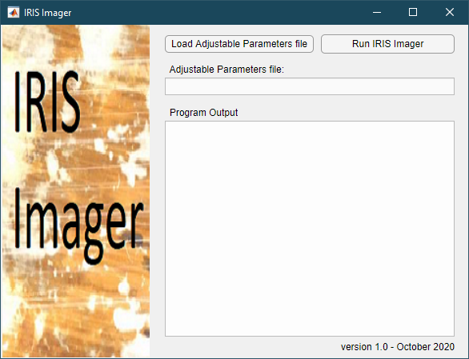

* First, load the adjustable parameters file. The location of the file will be shown in the text box. Once loaded, you do not need to reload the file between IRIS Imager runs.
* When the button “Run IRIS Imager” is pushed, you will be prompted to select the files for the starting and/or ending IRIS film images.
  + The name of the ending file will be used later to save the aligned images at a .mat file. The code will check to see if a .mat file of the appropriate name already exists. If so, it will load the .mat file and skip the alignment procedures. This allows the user to reanalyze images with different parameters without having to realign the images. If you wish to re-align a set of images, delete the corresponding .mat files first.

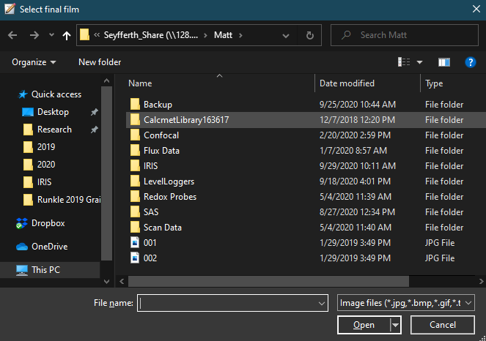

* A figure window will launch to allow the user to identify the corners of each film (Figure 1). Follow the prompts (start in top left corner and work clockwise).
  + Zoom in on the corner to enable a more accurate corner selection, using spacebar to advance once the zoom is completed. Note: Wait for the cursor to change to the crosshairs before zooming.This may take a few seconds for the first corner.
  + Select the corner and press spacebar.
  + Selected corners will be displayed with a +

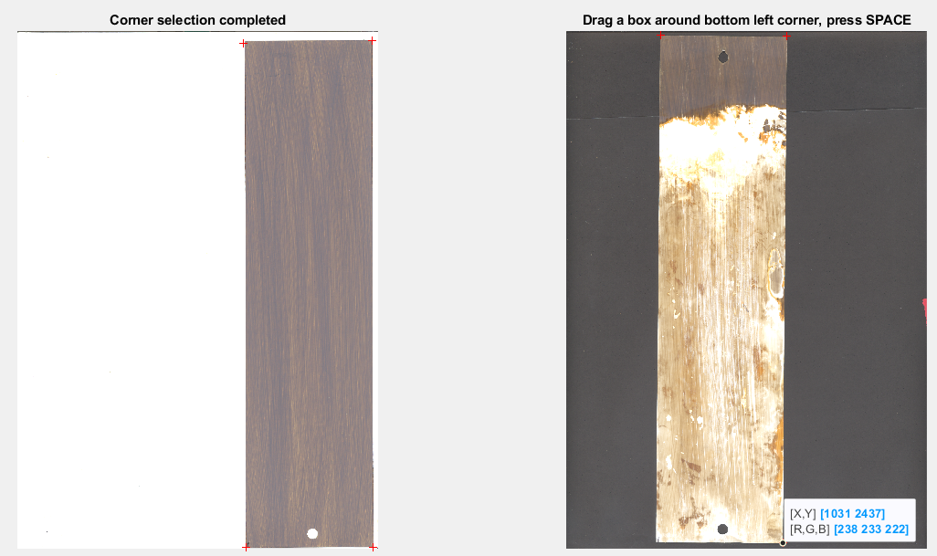

Figure – Corner selection window

* The window will close. If circles are present in the image (as set by the AdjustableParameters.xlsx workbook), a new window will open to identify circles (Figure 2).
* Circle identification is similar to corner identification. Simply select the center of the circle after zooming.
* Identified circles will be shown in red. If the identified circles do not match the actual circles, parameters will need to be adjusted in AdjustableParameters.xlsx. Check the size of the circles and also the color of the circles.
* Once all circles have been identified, there will be a lull in the program as it runs through a variety of calculations and outputs the data. The progress will be output on the user interface window and 2 system beeps will indicate a successful program run.

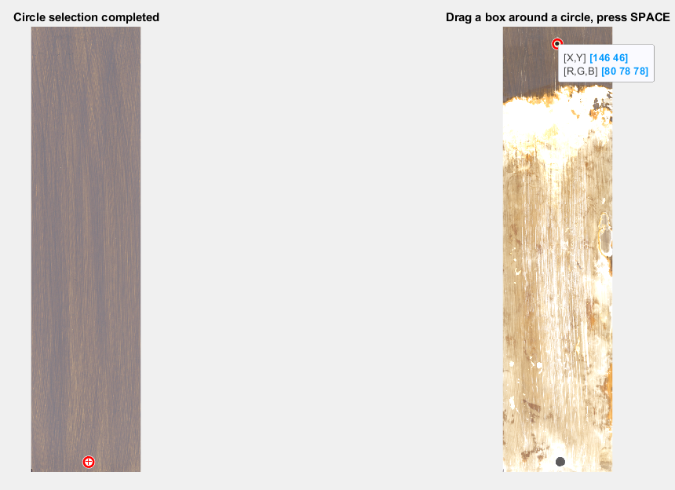

Figure – Circle selection window

* A number of figures will be generated. The figures vary depending on the type of IRIS film. None of these are saved by default, but can be saved by the user from the drop-down menus.
* The first figure “Aligned Images” shows the cropped starting and ending films with the circles masked out (Figure 3). The figure also shows an overlapped version of the films. Ideally, masked out circles should overlap perfectly. Also shown is a preliminary difference map.

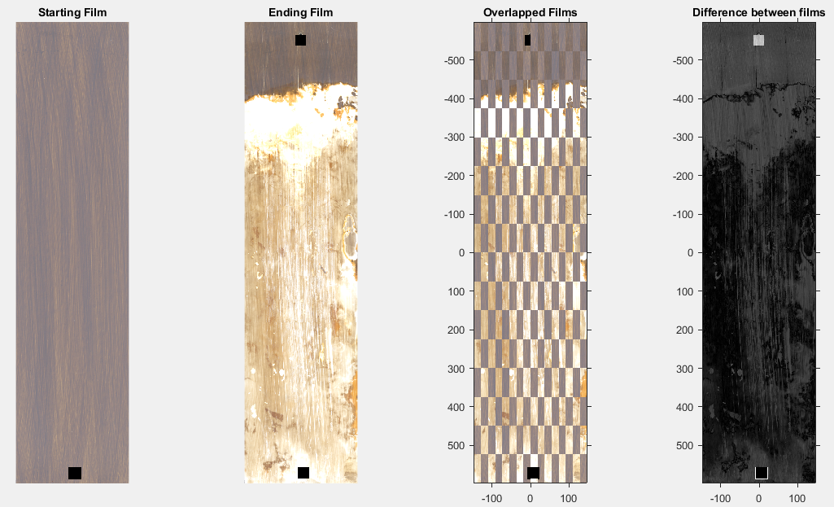

Figure – Aligned images window (only for Fe and Mn films)

* “CIELAB Difference Images” shows the differences between the starting and ending films for L*, a*, and b* (Figure 4). Black indicates no difference and white indicates complete difference. Values in the x and y axes are shown in pixels of the reduced image.

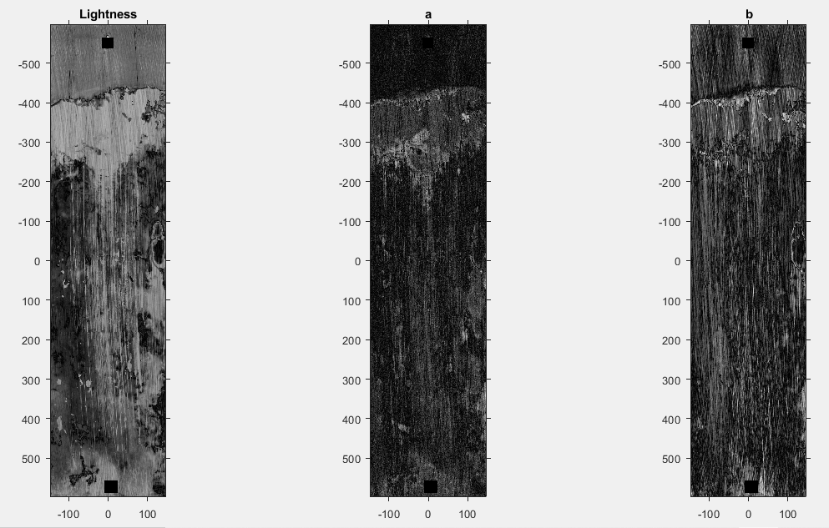

Figure – CIELAB difference images window (only for Fe and Mn films)

* “Clustered Images” shows the results of the image cluster analysis (Figure 5). For each film, the left image shows the clusters in false color maps. The right image shows the average color of each cluster matched to the closest Munsell color in “AdjustableParameters.xlsx”. Note that the masked out circle is considered one of the clusters.

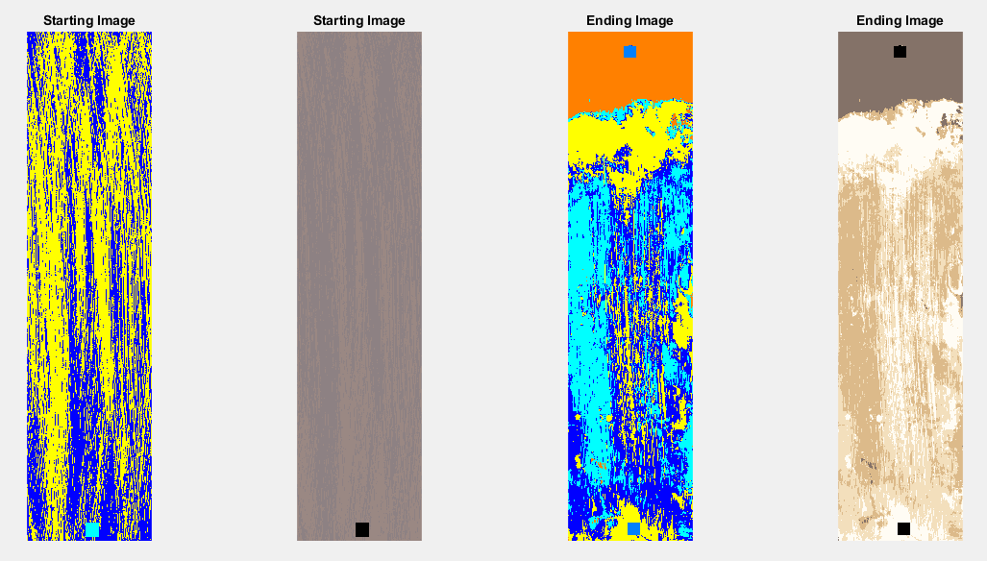

Figure – Cluster images window

* “Percent Removal” shows the calculated percent removal using the change in lightness (Figure 6). Values are shown in percent removal where black denotes 0% removal and white denotes 100% removal. These values do not adjust for the presence on Fe on Mn films.

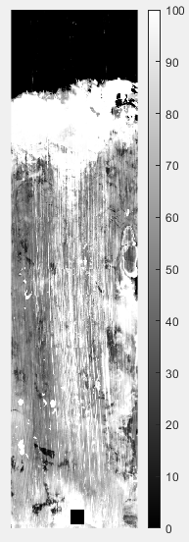

Figure – Percent removal window (only for Fe and Mn films)

* “Trends in percent removal” show the trends in removal across the film width and depth (Figure 7). The left plot shows the average removal across each column of pixels as you move across the film. The right plot shows the average removal across each row of pixels as you move down the film. The dotted lines are ± 1 standard deviation. The right panel also includes a piecewise function fit to the removal data. The piecewise function consists of two linear segments that are not required to be continuous. The program simultaneously fits the slope and intercept for both segments and the breakpoint.

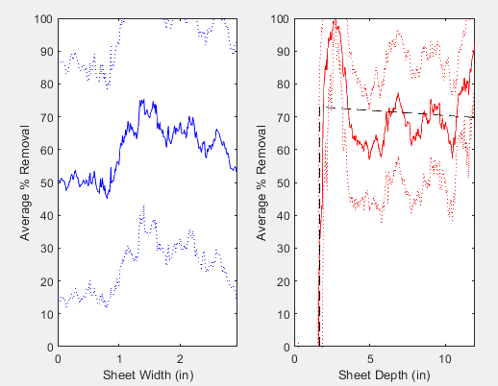

Figure – Trends in removal window (only for Fe and Mn films)

* “Change in Film Color” shows the change in a* and b* across the film (Figure 8). The left figure shows the a* vs. b* color space and the corresponding average values for the starting (circle) and ending (diamond) film. In this example, the film has become more yellow due to Fe precipitation. The other two plots show the change in a* and b* for each pixel on the film. Areas on the film where noticeable Fe precipitation occurred appear as bright yellow.

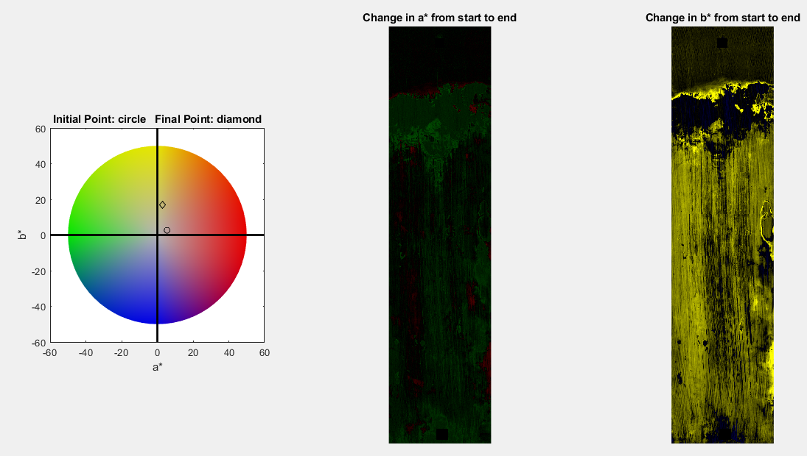

Figure – Change in film color window (only for Fe and Mn films)

* “Fe pixels (for use with Mn films)” shows visualizations of where the program identifies Fe pixels based upon changes in b* that exceed the threshold set in “AdjustableParameters.xlsx” (Figure 9). The left plot shows the ending scanned film. The middle plot identifies Fe pixels in white and non-Fe pixels in black. The bright yellow pixels (in b*) that were visibly orange are identified as Fe along with a large number of pixels on the left side of the film. These pixels on the left side seemingly have some Fe and Mn together. If the user decided to classify these as mostly Mn, this could be accomplished by adjusting the b* threshold in “AdjustableParameters.xlsx” to a larger value. The right plot shows the percent removal using L* as before showing any Fe pixels as 100% removal.

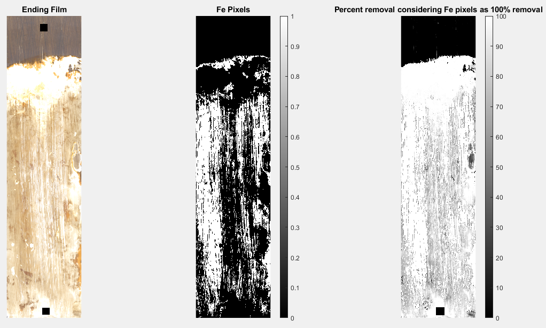

Figure – Fe pixels (only for Mn films) window

* “Trends in removal considering Fe pixels 100% removed” (Figure 10) is analogous to Figure 7, but it displays the changes in removal when considering the Fe pixels to be 100% removed. This piecewise function example demonstrates what appears to be 3 line segments but is actually a reflection of the discontinuity in the piecewise function. The middle segment (nearly vertical) is the plotter connecting the ends of the two line segments.

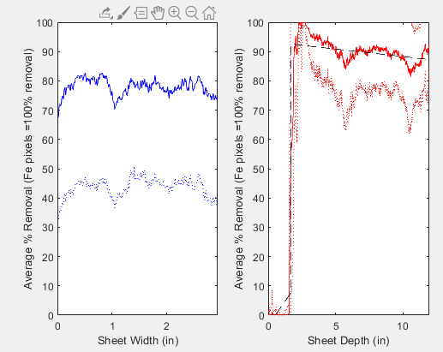

Figure – Trends in removal considering Fe pixels to be 100% removed (only for Mn films)

* “Sulfide plots” (Figure 11) shows the aligned film on the left and resulting S plots to the right. The middle plot is a binary image of S pixels. Pixels exceeding “Fe_b_Threshold” are considered Fe and are shown as black. All other pixels are considered S pixels (white). The right plot shows the relative intensity of S, calculated using the L* value associated with all S pixels.

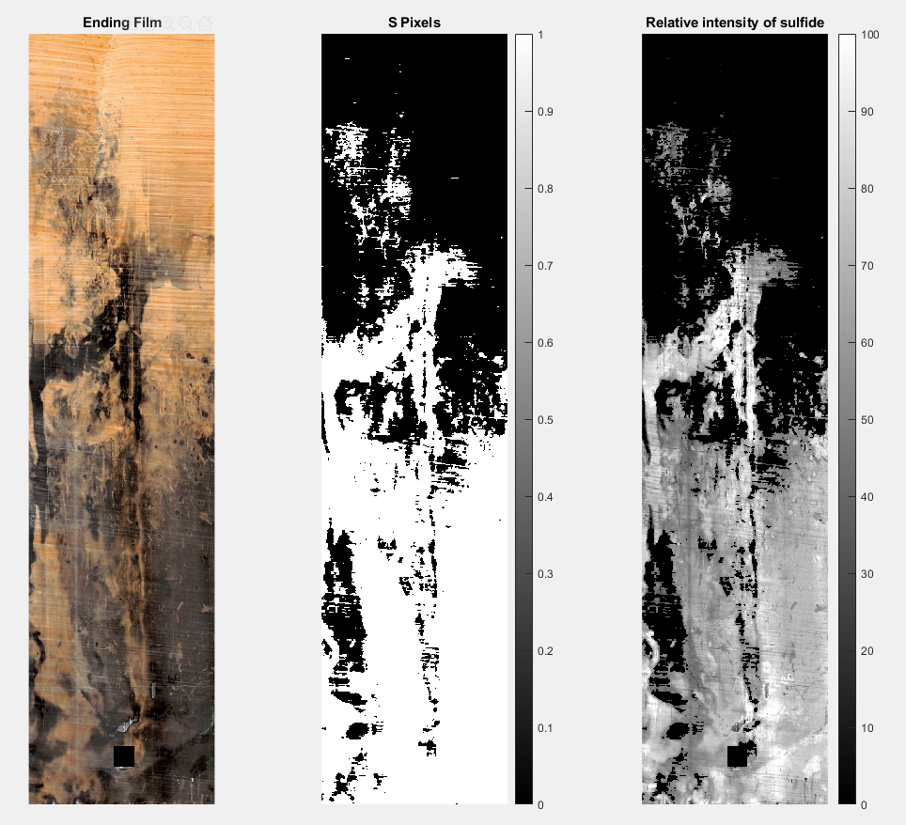

Figure – Sulfide plots (only for S films)

* “Trends in the relative intensity of sulfide” (Figure 12) summarizes the data shown in Figure 11 (right plot) averaged down and across the film. The left plot shows the average sulfide intensity across each column of pixels as you move across the film. The right plot shows the average sulfide intensity across each row of pixels as you move down the film. The dotted lines are ± 1 standard deviation. The right panel also includes a piecewise function fit to the data. The piecewise function consists of two linear segments that are not required to be continuous. The program simultaneously fits the slope and intercept for both segments and the breakpoint.

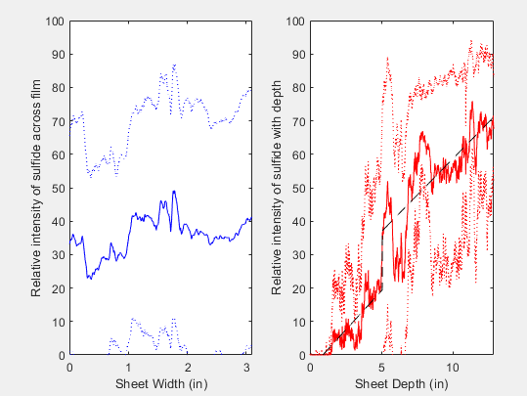

Figure – Trends in the relative intensity of sulfide

# Output Data

While the visual output is useful for qualitatively understanding paint removal on the films, quantitative data is written to the output file. A single output spreadsheet can be used to collect summary data from a number of IRIS films from a single project (or multiple projects). For each film analyzed (or re-analyzed), a row of output data is written to the spreadsheet. Below is a description of each column. Columns differ slightly between film types, where “Removal” values are given for Mn and Fe films while “Relative S Intensity” values are given for S films.

* Start File Name – the file name is the name of the initial film image
* End File Name – the file name is the name of the ending film image
* Sheet Width – the width of the sheet (after cropping) as measured by the program. The column will indicate that the value has units of inches, but the units will match whatever units are present in the scanner resolution (pixels/inch typically)
* Sheet Length – the length of the sheet (after cropping) as measured by the program. The column will indicate that the value has units of inches, but the units will match whatever units are present in the scanner resolution (pixels/inch typically)
* Mean % Removal – the average percent removal of paint on the film. This value is an average across all pixels on the film except the masked out circles.
* Median % Removal – the median percent removal of paint on the film. This value is a median of all pixels on the film except the masked out circles. Because the % removal is unlikely to be normally distributed across the film, the median will be a more robust estimate of “typical” paint removal on the film.
* Mean L value of ending film – the average L* value across entire ending film. A value of 0 denotes black while a value of 100 denotes white.
* Mean vertical standard deviation of removal – the standard deviation of removal for each column of pixels averaged together. This provides an estimate of removal heterogeneity in the y-direction.
* Mean horizontal standard deviation of removal – the standard deviation of removal for each row of pixels averaged together. This provides an estimate of removal heterogeneity in the x-direction. The ratio of vertical/horizontal standard deviations is one technique to measure gradients in removal on the film.
* Overall standard deviation of removal – the standard deviation of removal for all pixels
* Removal centroid in x – the centroid of removal in the x-direction, where 0 is defined as the center of the sheet and positive is to the right. A positive value of the centroid indicates more removal on the right side of the film.
* Removal centroid in y – the centroid of the removal in the y-direction, where 0 is defined as the center of the sheet and positive is down. A positive value of the centroid indicates more removal on the bottom of the film.
* Percent of Film with Fe pixels (for Mn films) – the percent of the film that was identified as Fe pixels. Not recommended for use on Fe films.
* Mean % Removal assuming Fe pixels as 100% removal (for Mn films) – the average percent removal of paint on the film when Fe pixels are treated as 100% removal. For Mn films with Fe present this yield the highest estimate of paint removal.
* Median % Removal assuming Fe pixels as 100% removal (for Mn Films) – the median percent removal of paint on the film assuming Fe pixels as 100% removal (for Mn Films). This value is a median of all pixels on the film except the masked out circles.
* Mean vertical standard deviation of removal assuming Fe pixels as 100% removal (for Mn Films) – the standard deviation of removal for each column of pixels averaged together assuming Fe pixels as 100% removal (for Mn Films). This provides an estimate of removal heterogeneity in the y-direction.
* Mean horizontal standard deviation of removal assuming Fe pixels as 100% removal (for Mn Films) – the standard deviation of removal for each row of pixels averaged together assuming Fe pixels as 100% removal (for Mn Films). This provides an estimate of removal heterogeneity in the x-direction. The ratio of vertical/horizontal standard deviations is one technique to measure gradients in removal on the film.
* Overall standard deviation of removal assuming Fe pixels as 100% removal (for Mn Films) – the standard deviation of removal for all pixels assuming Fe pixels as 100% removal (for Mn Films)
* Removal centroid in x assuming Fe pixels as 100% removal (for Mn Films) – the centroid of removal in the x-direction, where 0 is defined as the center of the sheet and positive is to the right when assuming Fe pixels as 100% removal (for Mn Films). A positive value of the centroid indicates more removal on the right side of the film.
* Removal centroid in y assuming Fe pixels as 100% removal (for Mn Films) – the centroid of the removal in the y-direction, where 0 is defined as the center of the sheet and positive is down when assuming Fe pixels as 100% removal (for Mn Films). A positive value of the centroid indicates more removal on the bottom of the film.
* Film change in a* -- the average change in a* across the entire film. Shown in Figure 8.
* Film change in b* -- the average change in b* across the entire film. Shown in Figure 8.
* Starting film cluster areas (%) – the area of each of the starting clusters (in percent of the film)
* Starting film cluster Munsell colors – the Munsell color for each of the starting film clusters. Note that the masked circles will be included as one of the clusters. If the number of clusters is adjusted in “AdjustableParameters.xlsx”, the headers will not move, but additional data will be added to the output file. These are the colors shown in Figure 5.
* Ending film cluster areas (%) – the area of each of the ending clusters (in percent of the film)
* Ending film cluster Munsell colors – the Munsell color for each of the ending film clusters. Note that the masked circles will be included as one of the clusters. If the number of clusters is adjusted in “AdjustableParameters.xlsx”, the headers will not move, but additional data will be added to the output file. These are the colors shown in Figure 5.
* Removal fxn Intercept1 – the intercept for the first segment of the removal function fit shown in Figure 7.
* Removal fxn Slope1 – the slope for the first segment of the removal function fit shown in Figure 7.
* Removal fxn Intercept2 – the intercept for the second segment of the removal function fit shown in Figure 7.
* Removal fxn Slope2 – the slope for the second segment of the removal function fit shown in Figure 7.
* Removal fxn Breakpoint (in) – the breakpoint in x between the first and the second segment of the removal function fit shown in Figure 7. The header is shown as having units of inches, although the units are derived from the units on the scan resolution (i.e., dots per inch). Zero is defined as the top of the film.
* Removal fxn … (no Fe) – the removal function described above using removal values assuming Fe pixels as 100% removal (for Mn Films). Shown in Figure 10.

If “OutputRemoval” in AdjustableParameters.xlsx was set to 1, then a tab will be added to the output data file for each film analyzed. The tab will have the calculated removal (or sulfide intensity) as a function of depth. These values can be averaged across desired depth intervals by specifying the averaging distance (OutputRemovalDepth). If this parameter is set to 0, then all data is output, allowing the user to recreate the right panel in Figures 7, 10, or 12.